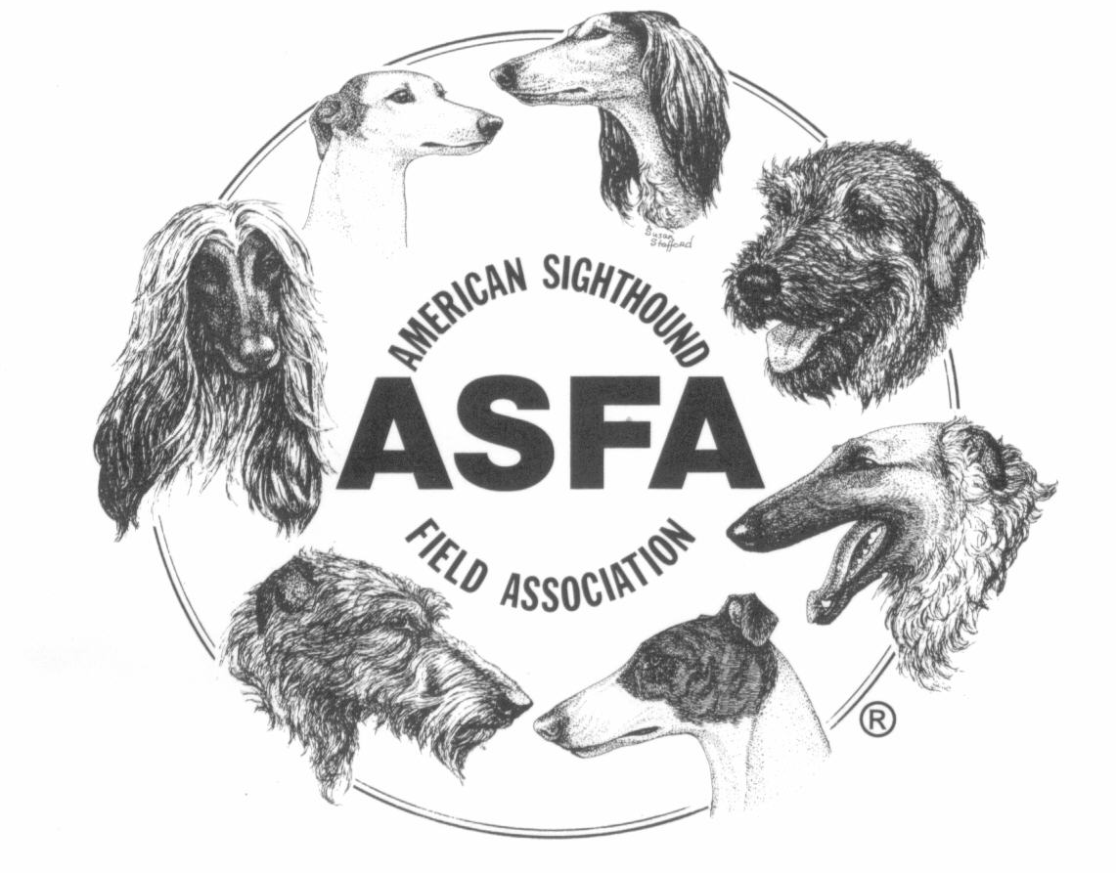
AMERICAN SIGHTHOUND FIELD ASSOCIATION

HUNTMASTER SPEECH

Instruct the handlers as follows:

- This will be a walking/standing start (whichever your club is using).
- Do not release your hound until the “T” of Tally-Ho.
- There will be a one to ten point penalty, per judge, for a pre-slip.
- I will ask if the handlers if you are ready, then ask the judges if they are ready, then the lure operator, and the handlers one more time.
- Please give a clear yes or no.
- Do not call to your dog while the course is in progress.
- If your hound does not run or returns to you before the course is over, I will ask you to retrieve the hound. Please do so immediately.
- Do not retrieve your hound before I ask you to do so.
- Any questions?

Huntmaster now asks:
“Judges, are you ready?
Lure Operator, are you ready?
Handlers, are you ready?”

Upon affirmative answers from all, raise your arm up into the air and twirl it to indicate to the Lure Operator to start the lure. Once the lure has moved a sufficient distance:

Drop your arm and yell “Tally-Ho!”

