20

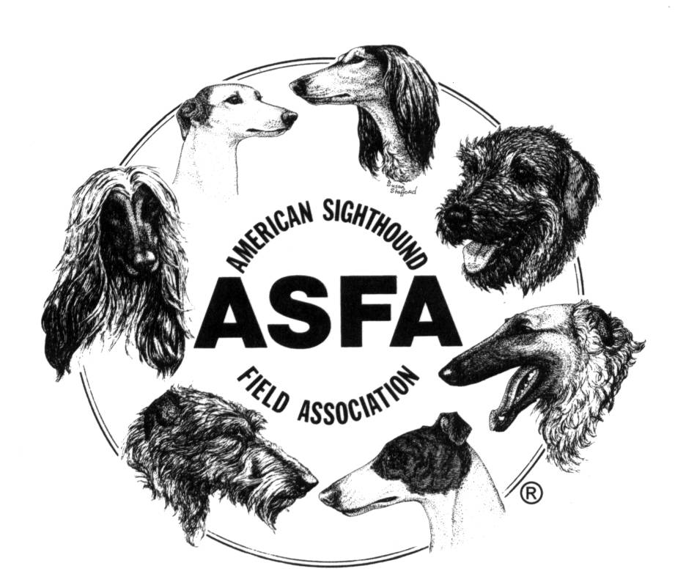

**American Sighthound**

**Field Association’s**

**Handbook for Huntmasters**

The Huntmaster is one of the most vital Field Committee positions in ASFA lure coursing. In partnership with the lure operator, the Huntmaster stands on the front line of hound safety. For that reason, the selection of Huntmasters should be carefully considered by host clubs. Huntmasters should be chosen and trained from the ranks of experienced lure coursers, not from those relatively new to the sport.

The purpose of this handbook is to provide guidelines and tips for both new and experienced Huntmasters, within the context of the official Huntmaster duties as defined in the ASFA Running Rules and Field Procedures for Lure Field Trials. When quoted, the Running Rules are shown in ***bold and italic*.**

**Qualifications for Huntmasters**

Although the Running Rules do not set forth any minimum qualifications for Huntmasters, there are a few qualifications that every good Huntmaster will have:

1. Lure coursing experience, both in running dogs and serving on the Field Committee. There is no magic number in terms of years of experience, lure trials attended, or courses watched; but a good Huntmaster will have enough experience in the sport to understand fully the duties of the Huntmaster, release and retrieval procedures, and what situations developing during a course are potentially dangerous to the hounds.

1

1. Good training. A good Huntmaster will have served an apprenticeship under an experienced Huntmaster, standing beside him or her and watching for several trials before serving as a Huntmaster.
2. The ability to assess potentially dangerous situations quickly and make rapid judgment calls about whether to stop a course or order a hound to be retrieved before the end of a course.
3. Good people skills, including patience with new handlers and the ability to be firm yet polite when instructing a handler to do something quickly.
4. The physical ability to move quickly to diffuse a potentially dangerous situation, such as removing tension in the lure line if a hound is caught in it.
5. A working familiarity with the Running Rules as they pertain to the duties of the Huntmaster.

**Duties of the Huntmaster**

1. ***The Huntmaster is a member of the Field Committee.***

This means that the Huntmaster may be called upon to serve on the Field Committee that rules on a protest. As a member of the Field Committee, the Huntmaster is also prohibited from partaking of alcoholic beverages until the completion of the trial. As a member of the Field Committee, the Huntmaster should set a good example and display good sportsmanship at all times, even when he/she is acting as a handler, because he/she is acting as a representative of both the host club and the ASFA.

1. ***The Huntmaster will be in complete charge of all hounds and handlers.***

This authority begins when the handlers approach the starting area and is concluded when the handlers have full control of their hounds and have left the finish area.

The Huntmaster, working with the lure operator, should determine where the starting point and the finish area will be. Many clubs use colored plastic disks or “Frisbees” to indicate where the handlers should stand with their dogs to begin the course. It is generally best to place the markers and the dogs on the same side of the line as the direction of the first turn, e.g., if the lure turns right first, the dogs should start on the right side of the line. This will reduce the chances of the dogs crossing the lure line and getting caught in it when they make that first turn.

19

2

18

The markers should be placed so that the yellow marker is on the Huntmaster‘s left, the pink is in the middle, and the blue marker is on the right as the Huntmaster faces the lures in the forward direction of travel. Make sure that there is enough separation between the markers and that the marker closest to the line is well away from it by at least three feet.

1. ***The Huntmaster shall call up each new course as each previous course is completed.***

If a Paddock Master is being used, the Huntmaster should tell the Paddock Master when he/she is ready for the next course of hounds. If no Paddock Master is being used, the Huntmaster should call up the next course in a loud voice, such as “Open Greyhounds, third course.” This lets all the handlers know where in the running order the trial is and when they should prepare their hounds for running.

It is usually advisable to wait until the lure operator has brought the lures around to in front of the start-finish area before calling up the next course. The Huntmaster should check on the condition of the lures at this point to determine if any of them need to be replaced.

As the handlers come to the starting area with their hounds, the Huntmaster should consult his/her draw sheets and insure that each hound is in the correct color blanket by asking the handlers to verify the name of the hound in each color blanket.

1. ***The Huntmaster insures that a handler handles but one hound in each course.***

Occasionally, multiple hounds in a course will be owned by one person. The owner or any other handler may slip only one dog in the course. Sometimes a handler will bring another person, such as a novice or a child, to the line. The Huntmaster should use his/her discretion as to whether to allow that additional person in the start/finish area, and should in all events make sure that the extra person is standing in a position that will not interfere with the release of the hounds or present any danger to the individual or the dogs at the end of the course.

3

1. ***The Huntmaster will check that blankets are properly secured and slip leads are in position for release. The Huntmaster will check that any elastic collars used for the purpose of identification fit snugly around the neck but are constructed to easily pull over the head and meet ASFA regulations as established in Chapter V, Section 15.***

A loose blanket on a hound will bring the course to a halt quickly because of the danger it presents to its wearer. So it is important to check that all blankets are properly secured and won’t likely come off during the course. Velcro fasteners on blankets are notorious for “letting go” during a course, particularly if a hound falls or rolls, so special attention should be given to those.

The Huntmaster should give special assistance to a new or novice handler in helping him get the sliplead readied for a quick release, being diplomatic and patient in giving such assistance.

According to ASFA rules, the identification band, if worn, should be no more than ¾” wide, and must be black or white.

1. ***The Huntmaster must explain release and retrieval procedures before each preliminary course only.***

This is the explanation commonly known as “the Huntmaster‘s spiel.” A typical one goes something like this:

“Handlers, welcome to the Heritage Coursing Club’s ASFA lure trial. I will ask the judges if they are ready, then the lure operator, then you the handlers if you are ready. Please give me an audible response when I ask if you’re ready. Do not release your hound until you hear the “T” in Tally ho! Do not retrieve your hounds until I instruct you to do so. If your hound fails to run or comes back during the course and I instruct you to retrieve it, please do so immediately for the safety of the other hounds. Any questions?”

The Huntmaster need not repeat this statement during final runs or run-offs, unless requested by a handler.

The Huntmaster should not hesitate to change the lure when it becomes either too small or tattered. Often new Huntmasters are reluctant to change the lure because they do not know how. Running a course with bags that are too small can result in the course being stopped because of unsighted hounds. Running the course with a tattered bag could result in the bag becoming detached. Often when this happens the course has to be stopped. At the very least someone, usually the huntmaster has to run out and retrieve the remnants. When this method of tying the lure is used these changes can be accomplished in just a few seconds even on the coldest, rainiest day.

4

Serving as Huntmaster can be a fun and exciting way to be on the “front lines” of a lure trial while serving the lure coursing fancy by helping to insure the safety of the hounds. While it is not a field committee position for everyone because it carries a lot of responsibility, it is certainly a position that many experienced people can hold. The ASFA urges both clubs and members of the lure coursing fancy to assist in training new Huntmasters, because they are essential to the safe and sporting perpetuation of lure coursing.

4.Finish tying by grasping both ends of the bag with one hand and the top of the loop with the other and pull hard. With just a little practice this knot can be learned. It is easy to tie but the real benefit is that it’s very easy to untie.

17

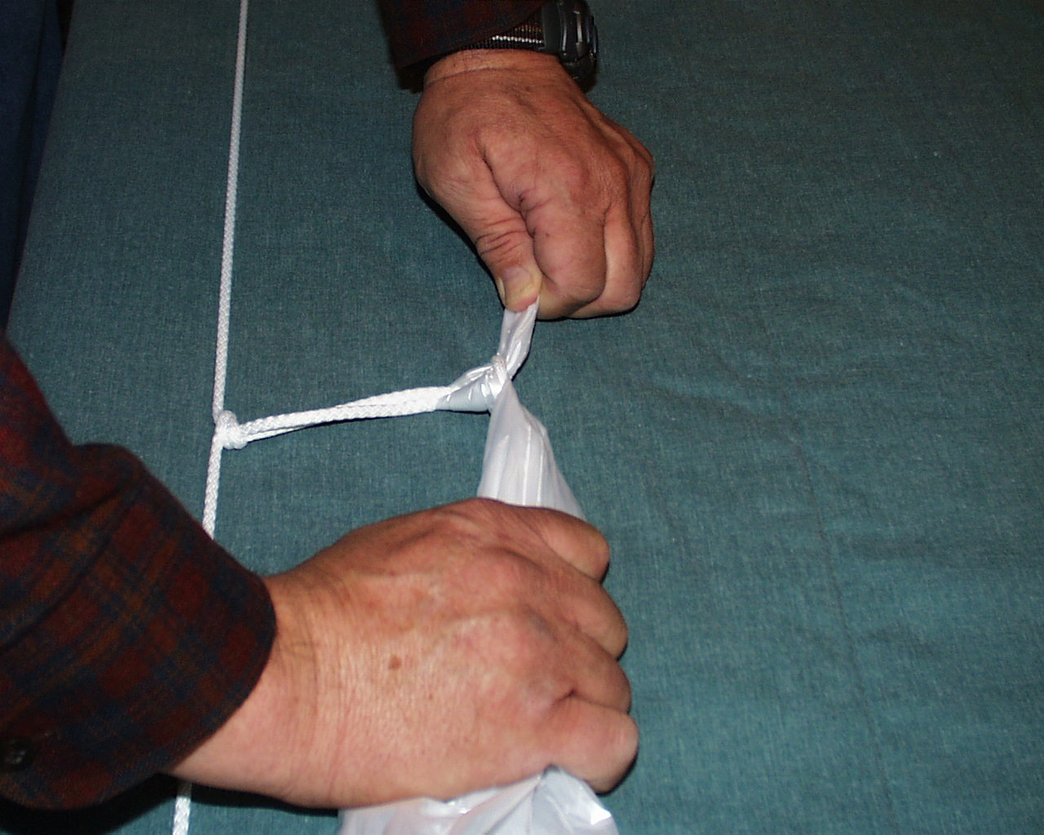

1. To untie the lure simply grasp both ends of the bag.

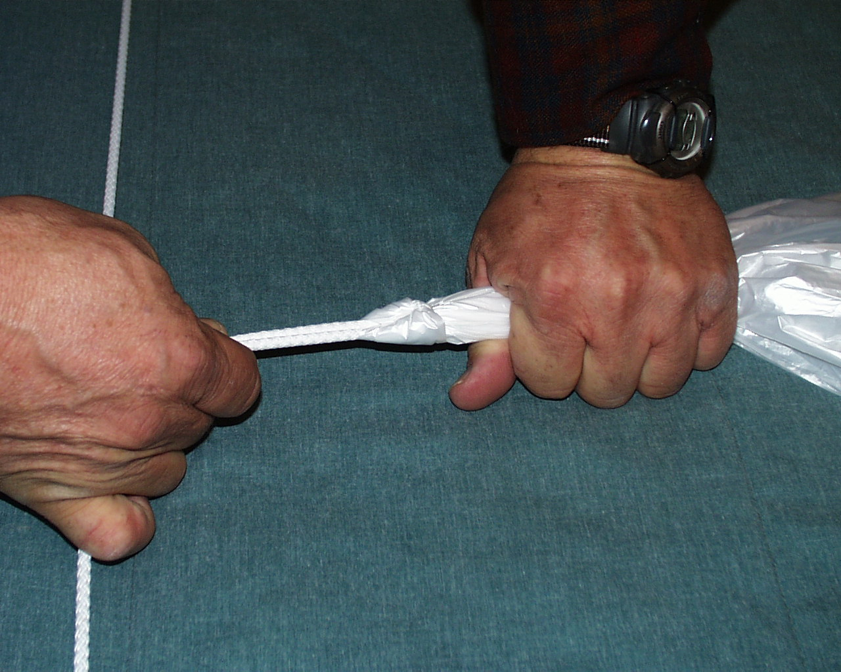

1. Now pull them apart firmly and the knot will open and the lure is untied.

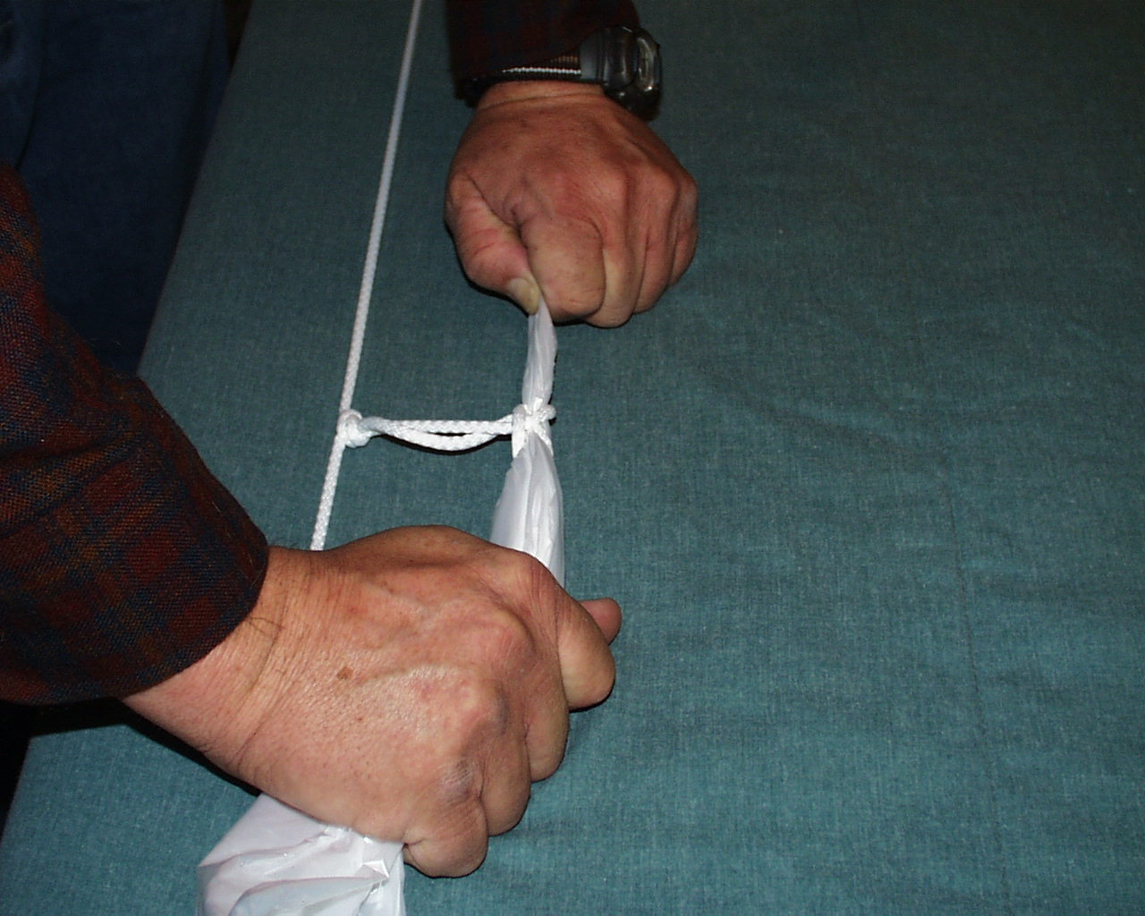

5

1. ***The Huntmaster shall stand in close proximity to, but not in front of, the handlers and hounds.***

It is best if the Huntmaster can stand where he/she can see the handlers, the judges, and the lure operator simultaneously without turning around, and in a position from which he/she can determine if there is a pre-slip. Usually, this will be behind the handlers and hounds, or to the side of them, but not so close as to intimidate a shy or soft hound.

1. ***The lure must be positioned in front of the hounds and in the direction in which it will travel before the signal is given to activate it. The lure shall not be brought up from behind the hounds.***

As noted above, the Huntmaster should wait to call up the next course of hounds until after the lure operator has brought the lures around and the lures have stopped in the position from which they will be set into motion at the Tally ho. If the lure operator has difficulty in getting the lures to stop in the desired position, the Huntmaster should manually place the lures in the optimum position by pulling on the lure line.

1. ***As the Huntmaster is facing the lure, the hounds shall be placed as follows: YELLOW on the left, PINK in the middle or to the right in braces, BLUE on the right in trios.***

As noted above, plastic colored disks are used by many clubs to help orient the handlers as to where and in what order they should stand with their hounds. “As the Huntmaster is facing the lure” means facing it in its forward direction of travel.

1. ***The Huntmaster shall not tease the hounds with the lure.***

Once the hounds are at the line, the Huntmaster should not pick up the lures for any reason. If the Huntmaster is in charge of tying on a new lure, he/she should finish that task and have the lures lying on the ground before the hounds come to the line.

1. ***The Huntmaster shall question, in the following order, the judge(s), lure operator, and handlers, “Are you ready?” and after affirmative answers, the course is begun for the purpose of determining a pre-slip.***

The Huntmaster should wait until he/she sees that all handlers have their slipleads arranged and their hounds held ready for the release before commencing the “Are you ready” questions. Affirmative responses from the judges and lure operators usually are given in the form of a raised hand from each. The Huntmaster should insist on hearing audible responses from the handlers in the form of “yes” or “ready” before he/she signals the lure operator to start the lure.

16

1. ***The Huntmaster provides a hand signal to the lure operator to start the lure.***

The hand signal typically consists of a raised arm, with the index finger pointed upward and the arm or hand being moved in a circular motion.

1. ***The Huntmaster gives the audible signals “tally ho” to release the hounds for each course, and “retrieve your hounds” when appropriate.***

The Huntmaster should call “Tally ho!” in a voice loud enough to be heard by the lure operator and the judges (unless they are in the middle of the field), but not so loud as to startle or frighten the hounds. Volume of the “Tally ho” may need to be louder if one or more of the hounds in slips are barking as the lure begins to move.

The Huntmaster should consult with the lure operator before the first course of both the preliminary runs and final runs about how much lead to give the moving lure before the “Tally ho” is called. Faster breeds like Greyhounds or Whippets will likely need a longer lure lead; slower or smaller breeds like Basenjis or Italian Greyhounds will need a shorter lead.

The Huntmaster should assist the lure operator in bringing the lure to a safe stop at the end of the course, well away from pulleys, the lure motor, or other obstacles. Depending on the terrain and the equipment used, the lure line may have a certain amount of “coast,” whereby the lures continue to move even after the lure operator stops depressing the lure button. In that case, the Huntmaster should place his foot on the line and put pressure on the line so as to provide a gradual braking action and bring the lures to a stop at a safe distance from any obstacles. It is often advisable to place a traffic cone near a pulley or lure motor to provide the hounds a visual warning of the obstacle.

6

1. Grab the plastic bag by the corner of the closed end. Pass the bag upward through the loop approximately 5 inches.

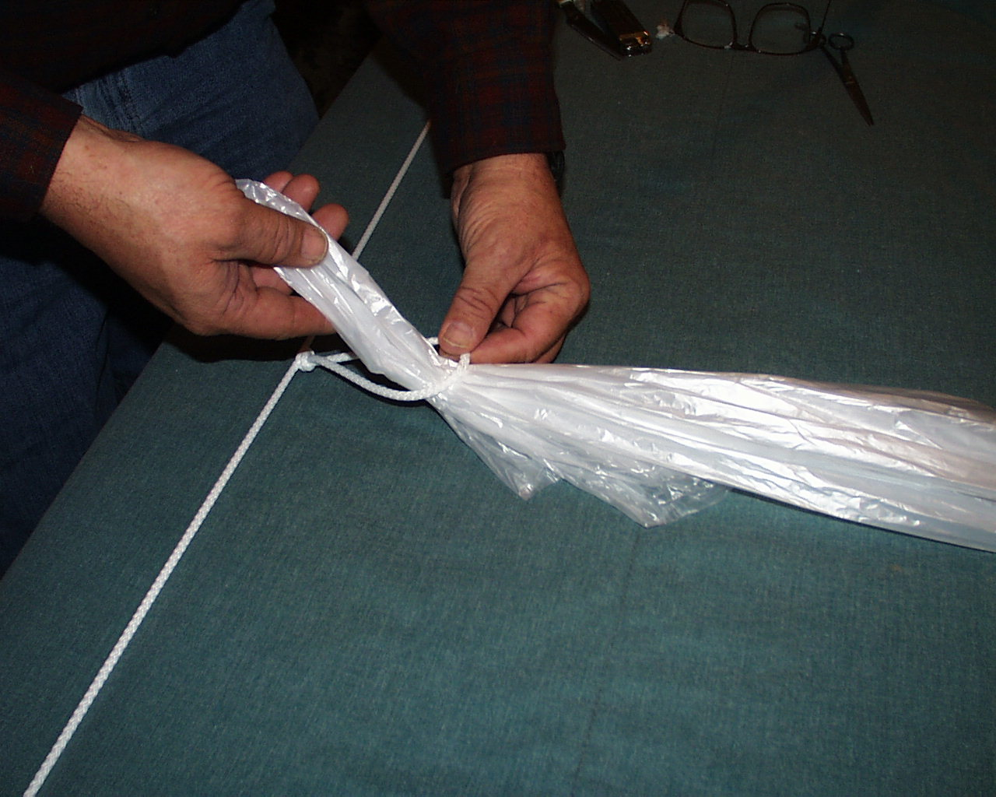

***Note:*** the open end should never be used to attach the bag. It will catch air, inflate and will not go through the hold down pulleys and can get caught on corner pulleys.

1. Wrap the bag around the loop.

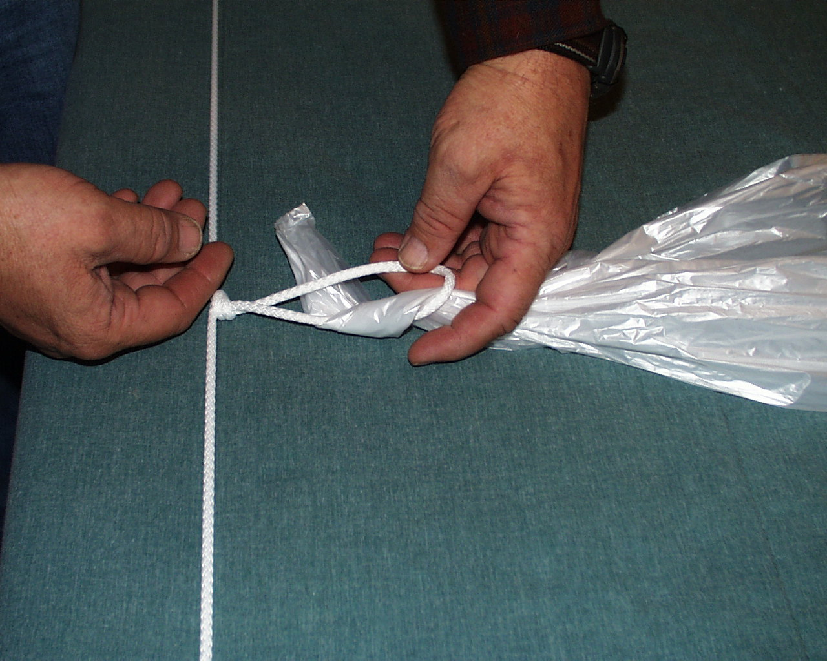

1. Insert the end downward through the loop.

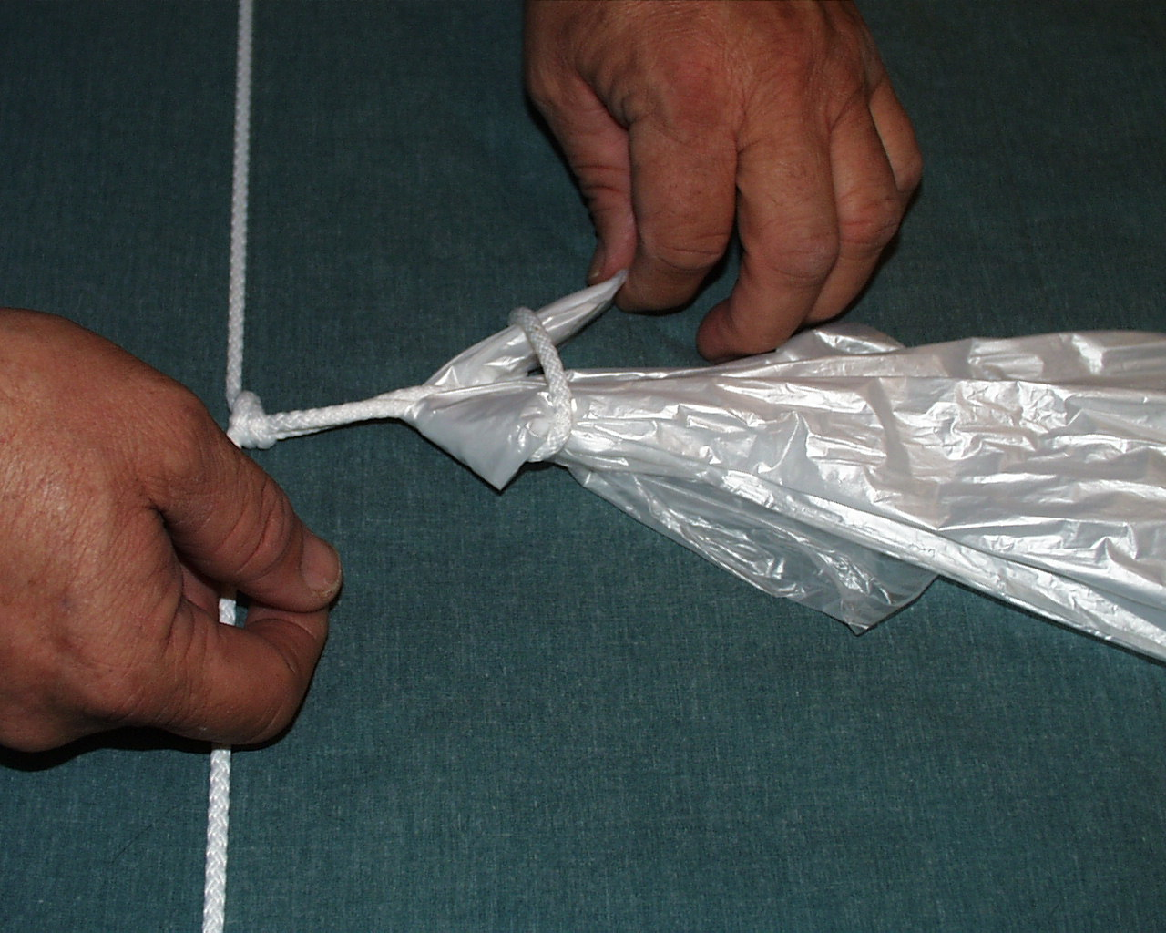

**Tying the Lure**

15

From time to time it is necessary for the huntmaster to replace the loops used for attaching the lures. Tying a “figure of eight loop” knot forms the loop. Double the line and create a *bright* approximately 3 to 4 inches long. (A bright is the working end of a doubled line.) Twist it to form a loop. Bring the bright around and tuck it through the loop to create the figure of eight and pull it tight. The loop should not be longer than 3 to 4 inches or it may wrap around hold down pulleys on windy days.

There are usually 3 loops spaced approximately 8 feet apart. Do not separate the lures more than 8 feet apart. When lures are spaced too far apart it can cause the trailing hounds to cut.

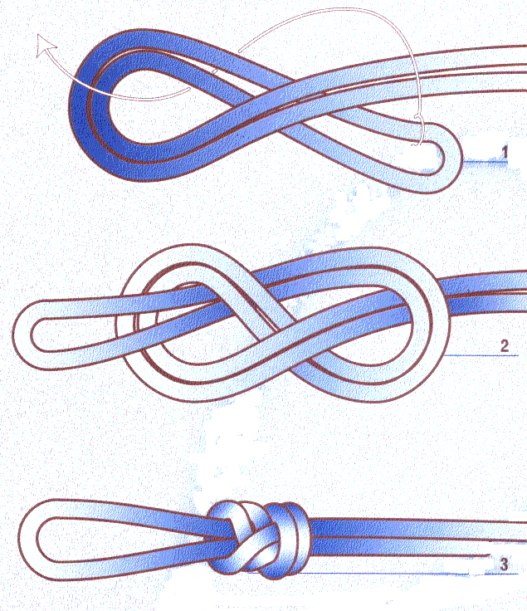

Bright

It is usually necessary for the lures to be changed frequently during a trial. It is helpful when all the Huntmasters use the same method to tie the lures. What follows is the recommended method for tying lures.

The call “retrieve your hounds” should not be made until the lures have stopped, the hounds have slowed and are at the lures. Some handlers will begin moving toward the hounds before the “retrieve your hounds” is called. If that occurs, the Huntmaster should call them back immediately and firmly, as a collision between a fast moving hound and human can result in serious injury to both.

14

Occasionally, a handler will request that the lures be brought in closely so that a difficult-to-catch hound can be retrieved immediately. When possible, such a request should be honored, but it requires attentive action by both the lure operator and the Huntmaster to make sure the lure is stopped safely.

After “retrieve your hounds” is called, the Huntmaster should assist any handlers who are having difficulty getting their dogs off the lure, but should exercise caution to make sure that he/she is not bitten by an excited hound. This is a time to be especially watchful, as hounds can become caught in the line if they or other hounds are pulling or twisting as they are biting at the lure. Huntmasters should always carry a knife to cut the line if a hound becomes entangled, although often the fastest measure that can be taken is to remove the lure line from a pulley or the main wheel and thus remove the tension on the line.

The Huntmaster should also watch the hounds at the end of the course for any aggressive behavior that should be reported to the judges.

1. ***Hounds should not be slipped before the sound of the “T” in “tally ho.” The Huntmaster will notify the handler of the pre-slipped hound and the judge(s) of any pre-slips immediately at the end of each course. If the Huntmaster fails to notify the judge(s) of a pre-slip, then to all intents there has been no pre-slip, but the judge(s) shall have the prerogative to question the Huntmaster at any time if the release seems questionable.***

If a handler has released his/her hound before the “T” in “Tally ho”, the Huntmaster should notify the handler as soon as he/she has his/her hound under control at the end of the course that he/she will call a pre-slip. He/She should then approach the judges and say, “There was a pre-slip of the (yellow, pink, blue) hound.”

7

1. ***The Huntmaster may order a hound that fails to run at the tally-ho, or returns to its handler while the course is in progress, to be immediately retrieved. The Huntmaster shall notify the judge(s) of an immediate retrieval at the completion of the course, but the judge(s) shall have the prerogative to question the Huntmaster at any time if the immediate retrieval seems questionable. In the case of a restart, it will be up to the judge(s) to determine whether a retrieved hound shall be included in the restart.***

Hounds who fail to run at the “Tally ho” or who come back to their handler at some point during the course pose a serious threat of collision and resulting injury to the other hounds in the course, particularly at the end of the course, if they are left unrestrained. Therefore, the Huntmaster should order a non-running or returning hound to be retrieved immediately by saying to the handler, “Retrieve the (yellow, pink, blue) hound, please.” Occasionally, a handler will not heed the request or will move slowly in making the retrieval. Time is of the essence in an ordered retrieval, as a non-running hound may suddenly decide to take off toward the lure and get out of its handler’s reach. In that instance, the Huntmaster should repeat the request, loudly and firmly, adding whatever command language appears to be appropriate.

Whether the handler actually retrieves the hound before the end of the course, the Huntmaster should approach the judges after all handlers have their hounds under control at the end of the course and say, “I ordered an immediate retrieval of the (yellow, pink, blue) hound.”

1. ***The Huntmaster will cause the lure to be stopped upon a pre-slip and restart provided no tally ho has been sounded.***

Occasionally, a handler will lose control of a hound well before the “Tally ho” is called, and the hound will go running on its own. If the Huntmaster has not called the tally ho, then he/she should say in a loud voice to the lure operator, “Stop the course!” and tell the handler to retrieve his/her hound. Once the handler has regained control of his/her hound, and is again ready at the start line, the Huntmaster should repeat the series of “Are you ready” questions to the lure operator, the judges, and the handlers.

13

8

There are several benefits to using this knot: 1) it’s easy to learn and easy to tie; 2) as it tightens, it gets smaller and smaller. The principal advantage however is that the string (line) passes through the center of the knot which decreases line breakage.



The knot in the illustration below is an “overhand knot” and is commonly used to tie the line. It can be tied quickly but may cost a lot of time in the long run.

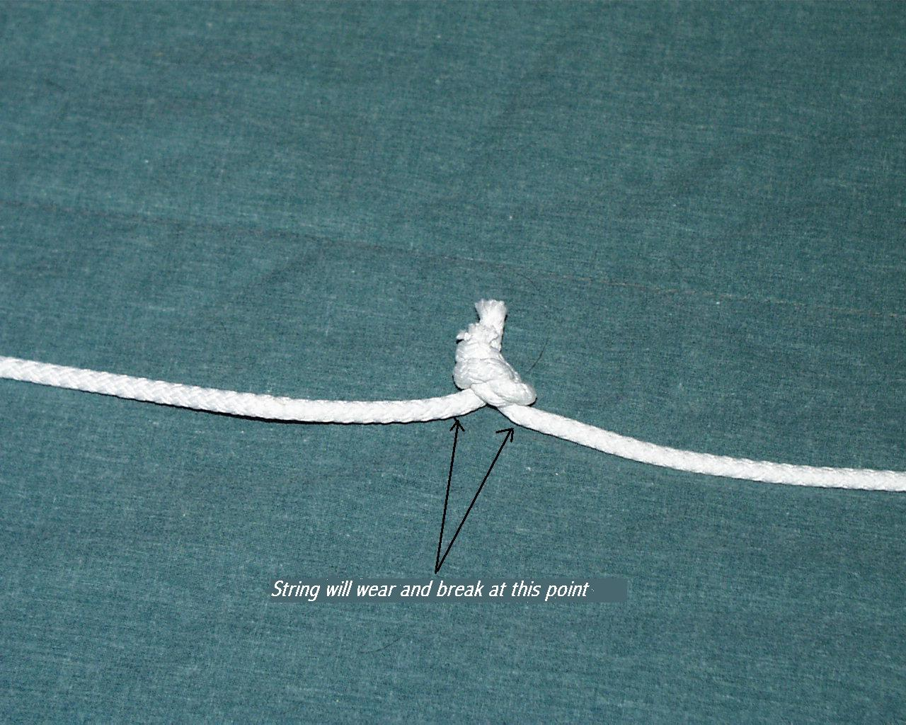

The problem with this knot is that the string (line) comes from the bottom of the knot and is dragged along the ground at that point. Often when the line breaks it will be at this type of knot. Frequent line breaks will extend the time required to finish the trial.

**Tying the Knot**

The following is an illustration of a “Fisherman’s Knot”. This knot is recommended because it is easy to learn and tie. There are other advantages that will be discussed later.

Lay both ends of the strings (lines) parallel, tying an identical overhand knot with each working end to enclose the adjacent standing part, then tighten the knots until they are embedded together as shown. While this may look complicated, it’s not. It is just tying one end of the string (line) to the other using a simple overhand knot. It’s really very easy and can be learned with a little practice.

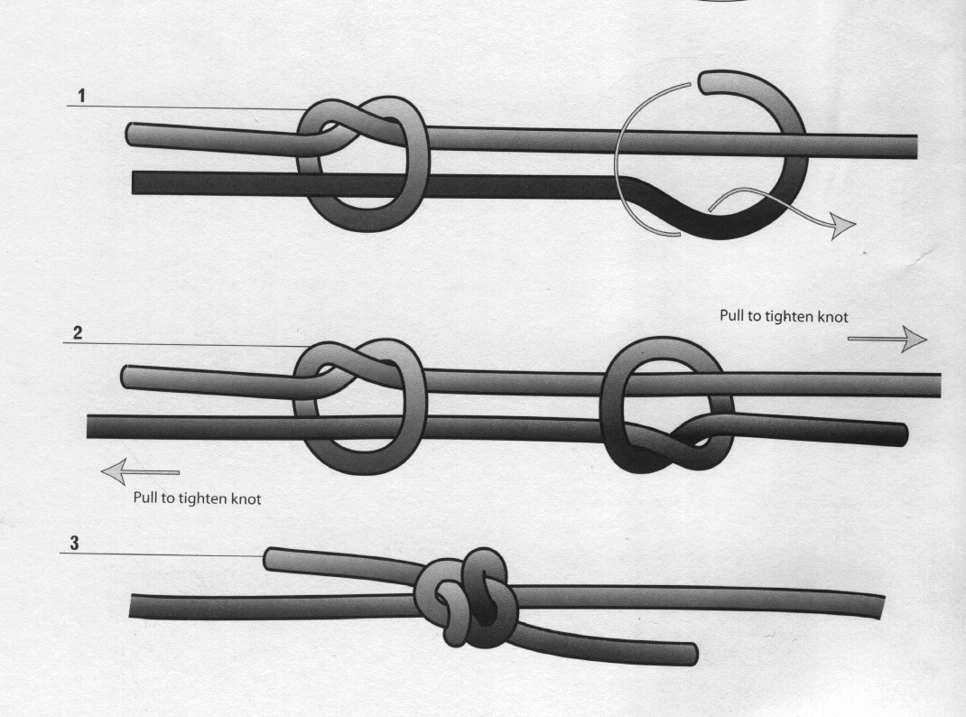

This is a picture of the finished product.

12

1. ***The Huntmaster will inspect the lure before every course and replace it if needed.***

The Huntmaster should check the lures for “tails” that may fall off during the course and create a distraction to one or more of the hounds; for holes in the lures that may cause them to get caught on a pulley or hold-down; and for lures that have become too small. He/She should consult with the lure operator as to whether one or more lures should be replaced.

There is an easy and simple way to tie a lure on to the lure line that makes it very easy to remove for a replacement lure (see Tying the Knot, below). If plastic bags are being used for lures, first turn the bag inside out. Grasp one corner of the closed end of the bag and create a “tail” of about 8 inches in length. Hold the loop in the line open with one hand. Pass the “tail” of the bag through the open loop from the top, then bring it to the right and then over and around both “arms” of the loop, coming back up through the loop from the “underside.”

1. ***The Huntmaster will neither pick up nor authorize anyone to pick up or touch the lure until such time as all hounds are on lead and moving away from the finish line, unless the lure is lying on the ground in the clear.***

Moving the lure while the handlers are trying to get their hounds under control and on lead may cause the hounds to get away from their handlers or delay their moving off the field so that the next course can commence. Picking up the lure line to retrieve a hound should not be done, as it may injure a hound. The lure operator should not move the lure until the handlers from the previous course are moving off the course with their hounds fully under their control, and the Huntmaster should wait until that time to inspect or change the lures.

1. ***The Huntmaster insures that the lure be re-strung immediately upon completion of each course.***

If drag lure is being utilized, the Huntmaster is in charge of the restringing team and insures that they re-string the lure as soon as possible after the course is completed. If continuous loop is being used, the Huntmaster should assist the lure operator in bringing the lure around from the finish to the start by calling out “Hold your hounds!” to let all handlers know that the lure is about to move.

9

1. ***The Huntmaster shall notify the inspection committee if any of the hounds appear lame.***

13

As a courtesy to handlers, it is advisable that the Huntmaster tell the owner of a hound that his/her dog appears to be lame. This will give the handler a chance to re-check the hound and perhaps scratch him from further running without the necessity of involving the inspection committee. However, if the handler chooses to ignore the advice of the Huntmaster, the Huntmaster must then advise the inspection committee of the possible lameness of the dog.

1. ***Shall notify the judge(s) of any occurrence at the beginning or the end of a course which might be grounds for excusal, dismissal or disqualification. Appropriate action is at the sole discretion of the judge(s).***

The lure coursing experience of the Huntmaster must be brought to bear in these instances in order to distinguish between true unprovoked aggression and “lure possessiveness,” whereby one hound barks or growls at another hound who is going for “his” lure at the end of the course. At the beginning of the course, the Huntmaster should be aware of any aggression by one hound going into slips toward another hound on the line. Any occurrence the Huntmaster sees that might constitute interference or fighting should be reported, immediately and factually, to the judges, and they will take appropriate action.

1. ***The Huntmaster shall inform immediately the handlers of all hounds in a course that is called a no-course or a course in which a dog is dismissed or disqualified.***

In the event that a course is stopped in mid-course due to mechanical problems or occurrences between dogs that lead to dismissal or disqualification, the Huntmaster should immediately instruct the handlers to retrieve their hounds. The Huntmaster should then consult with the judges to determine where they want the re-start of the course to occur. When the re-start location has been determined, the Huntmaster should inform the handlers and assist the handlers in getting their dogs there and set up for the re-start.

In the event of a dismissal or disqualification of a dog by the judges, the Huntmaster should first inform the handler of that dog of the judges’ action, then inform the handlers of the other dogs in the course of that action.

10

1. ***The Huntmaster may signal the lure operator to stop the lure any time a hound becomes entangled in the string or when a potentially dangerous situation may develop.***

This is one of the most important duties of the Huntmaster. During the running of the course, the Huntmaster should stand where he/she can see all dogs in the course during the entire course, without blocking the view of the handlers. There are a variety of potentially dangerous situations – a hound becoming entangled in the string, a coursing blanket coming partially off a hound, a hound’s being well off course and posing a collision risk to the other hounds, and an obviously injured hound are but a few examples. If any of these – or countless other real or potentially dangerous situations – develop during a course, the Huntmaster should act quickly and decisively and call “Stop the course!” in a loud voice to the lure operator, more than once if necessary.

If a hound is off course but the Huntmaster feels he/she poses only a small risk of collision, he/she should watch the off course hound for the lure operator, calling out to the lure operator the location of the errant hound.

There are no hard and fast rules for these situations. Rather, the Huntmaster must rely on his/her own experience and judgment, remembering that the safety of the hounds is paramount. When in doubt, stop the course.

1. ***A Huntmaster shall not huntmaster for any stake or flight in which any hound is entered that he/she owns or co-owns or is owned or co-owned by a member of his/her immediate family or residence.***

Because the Huntmaster may be involved in discretionary calls such as pre-slips or informing the judges of aggression at the beginning or end of a course, it would be a conflict of interest for an individual to huntmaster a stake or flight in which a dog he/she has an interest in is running.

11